**HOW LONG WILL IT TAKE YOU TO PEDAL TO 1 KILOMETRE?**

**Try your luck at Porchester Junior School**

**12noon until 4pm on Saturday**

**There’s a prize for the fastest**

**Have as many goes as you like – it’s free!**

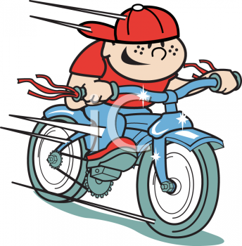

**Over 16s only**

The winner will be notified by phone

Prize will be awarded at the Community Celebration in the Marquee at St James, 4pm on Sunday